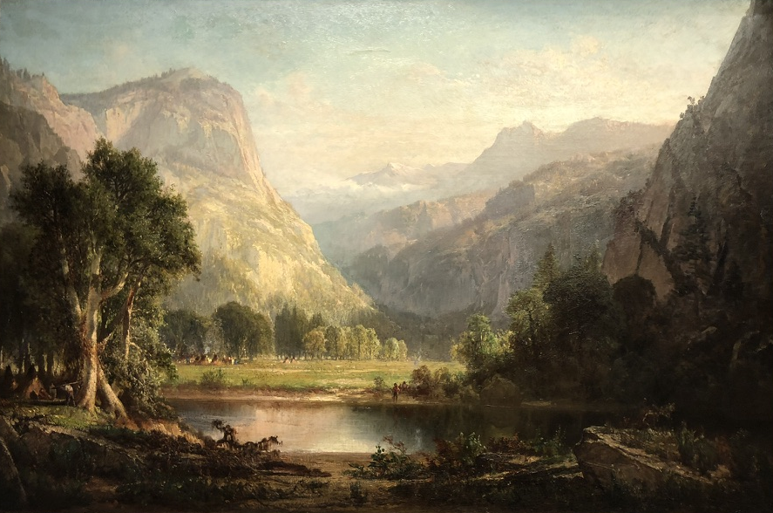
Extended Object Label-Writing Sample

In the space provided below, please draft a simple 50-word (or less) object label for the image pictured above. For more information about writing effective interpretive material, please visit: Writing Effective Interpretive Labels for Art Exhibitions: A Nuts and Bolts Primer. Email this document as an attachment to Laine@zanesvilleart.org to complete your curatorial intern application.

Thomas Hill
American (born England) 1829–1908
Indian Encampment, Yosemite Valley
1863
Oil on canvas

